


PORTABLE H₂ LEAK DETECTOR

AURIGA
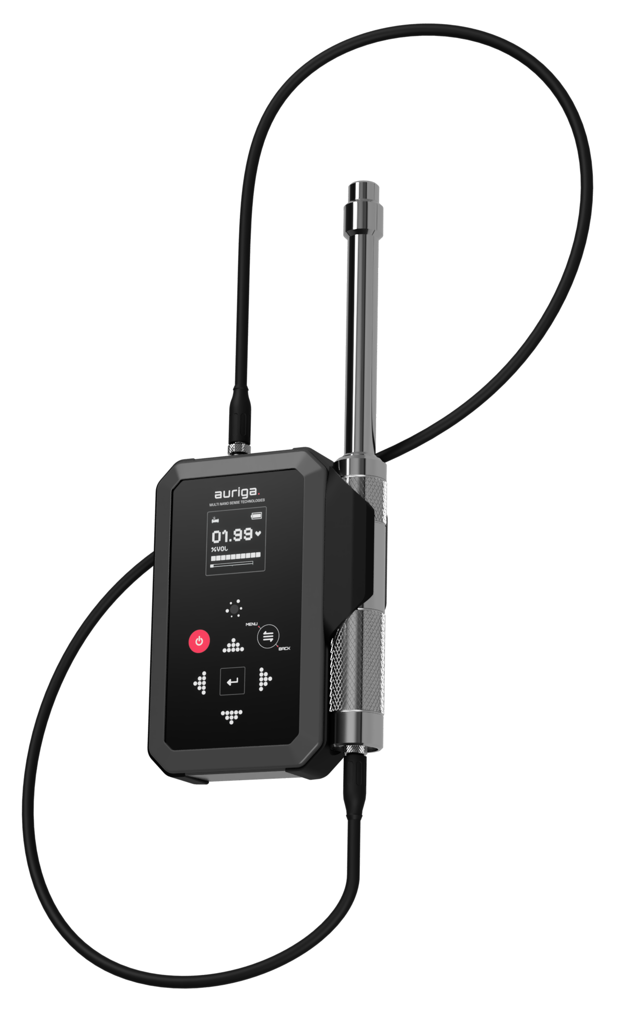
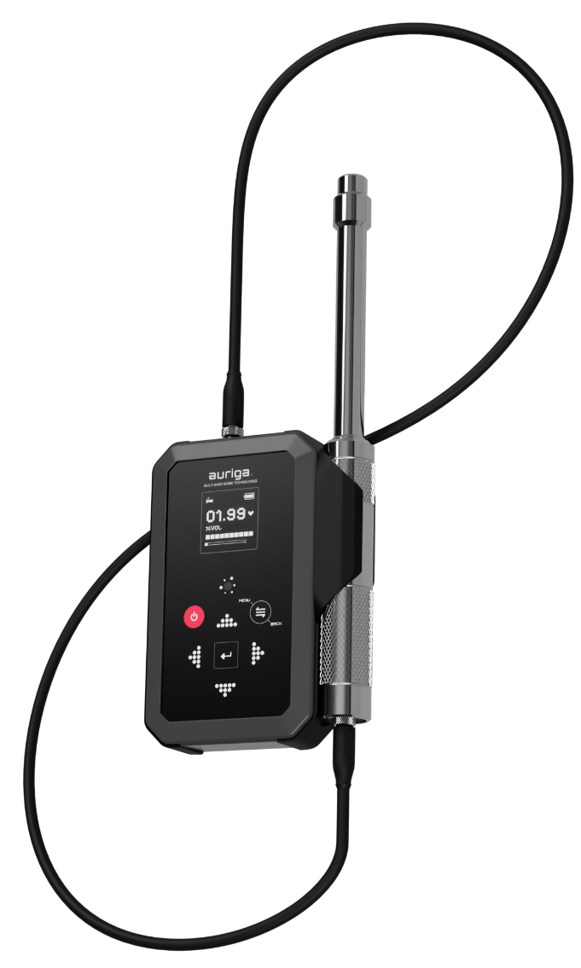
AURIGA
Portable Hydrogen Leak Detector

Product Features:

- Patented Solid State Electrochemical Hydrogen Sensor with Solid Electrolyte and Novel Reference Electrode.
- Extremely Compact Design
- Selective and Specific to Hydrogen
- High Sensitivity to Minute Leaks – 10 ppm
- Sub-second Response Time
- Widest Operating Range
- Over-Exposure Damage Resistant
- Operating Life of 5 years
- Audio & Visual Perception of H₂ Leaks
- Smart Algorithms for User Friendly Interactions
- Long Duration Battery Backup
- Probe Options & Extension Accessories
- Single Hand Operation Variants
- Internal Memory for Records
- USB C-Type for Charging & Data Transfer
- IP 67 Ingress Protection

Product Benefits:

- Enhanced Safety: User can pin-point very low levels of leak at very early stages and act proactively to fix the leaks.
- Enhanced Operator Efficiency: Checking leaks takes 10X less time compared to traditional H₂ leak detectors, due to sub-second response and recovery time.
- Design Advantage: Small and easy to handle. Extended and flexible probe design enables insertion of the probe into high or small and space constrained locations.
- No Damage on Over-Exposure: Sensor can be taken as close to the leak source as needed, without worrying about sensor damage.
- Saves operational cost: No false alarms avoiding unnecessary down time.
- Comprehensive AMC: Periodic calibration and cashless product replacement even beyond warranty period.
- Product Upgrade Plans: Buy back options to upgrade your safety systems with our latest and best in class offerings.

Technical Specifications:

Hydrogen Concentration Terminology Conversion Table for Ease of Reference
Hydrogen Lower Explosive Limit (‘LEL’) – 4% H₂ v/v in Air

250% H₂ LEL = 10% H₂ v/v in Air = 1,00,000 ppm H₂ v/v 125% H₂ LEL = 5% H₂ v/v in Air = 50,000 ppm H₂ v/v 100% H₂ LEL = 4% H₂ v/v in Air = 40,000 ppm H₂ v/v 50% H₂ LEL = 2% H₂ v/v in Air = 20,000 ppm H₂ v/v 25% H₂ LEL = 1% H₂ v/v in Air = 10,000 ppm H₂ v/v 1% H₂ LEL = 0.04% H₂ v/v in Air = 400 ppm H₂ v/v

Selectable Ranges | Range 1 | Range 2 | Range 3
Start | 0 ppm | 0 ppm | 0 ppm
Span | 5000 ppm | 5 vol% | 10 vol%
Unit of Measurement | ppm to vol%: Auto-scaling  %LEL: Long press toggle | ppm to vol%: Auto-scaling  %LEL: Long press toggle | ppm to vol%: Auto-scaling  %LEL: Long press toggle
Resolution | 0 to 1000 ppm = 1 ppm  1000 to 5000 ppm = 10 ppm | 0 to 1000 = 1 ppm  1000 to 5000 = 10 ppm  0.5% to 5% = 0.01% | 0 to 1000 = 1 ppm  1000 to 5000 = 10 ppm  0.5% to 5% = 0.01%
Minimum Detection Limit (MDL) | 10 ppm | 10 ppm | 10 ppm
Accuracy  (MV=Measured Value) | 0 to 10ppm: ±5ppm  10 to 100ppm: ±20 ppm  100 to 1000ppm: ±100 ppm  1000 to 5000ppm: ±5% of MV | 0 to 10ppm: ±5ppm  10 to 100ppm: ±20ppm  100 to 1000ppm: ±100ppm  1000 to 5000ppm: ±5% of MV  0.5% to 5%: ±2% of MV | 0 to 10ppm: ±5ppm  10 to 100ppm: ±20ppm  100 to 1000ppm: ±100ppm  1000 to 5000ppm: ±5% of MV  0.5% to 10%: ±2% of MV
Detection Certainty | 100%
Cross Sensitivity | No cross sensitivity to other combustible and reducing gases.
Selectivity & Specific | H₂ only
Background Gas Options | - Air  - Oxygen  - Inert – Nitrogen, Argon and Helium  - Combustible Gases  Background gas must be selected by the customer at the time of placing order as this choice has a bearing on the instrument calibration settings.
Response Time | T10: Less than 0.5 seconds | T90: Less than 3 seconds
Operating Temperature | -20℃ to +65℃
Storage Temperature | -20℃ to +65℃
Operating Humidity | Up to 99% RH at 40℃ (Non-condensing) for sensor probe.
Operating Pressure | 1 Bar to 1.2 Bar
Storage Conditions | 0℃ to +45℃. RH% < 90%. Store in a cool and dry place.  Device must be stored in power OFF mode.  Carrying case included.
Area of Deployment | Safe Area. This instrument should not be deployed in a Hazardous Area.
Compatible Batteries | 3 x Rechargeable AA Ni-MH batteries with over-charging protection and battery diagnostics.  Batteries supplied in packed condition separately.
Compatible Charger | Standard USB C-Type charger used with mobile phones.  Charger to be ordered separately.
Battery Life on Single Full Charge | 12 hours to 24 hours based on the number of times H₂ is detected and power consumed by the buzzer and other visual indications.
Resistant to Over-Range Exposure | No damage on short term exposure to even 100% pure Hydrogen  - In-house lab tested for 15 second exposure to 100% pure Hydrogen.  - In-house lab tested for 5 minutes exposure to 40% Hydrogen in Nitrogen.  - In-house lab tested for 10 minutes exposure to 20% Hydrogen in Methane.
Single Shot Calibration | User-friendly calibration routine taking less than 10 minutes, using a single certified reference gas mixture. Calibration kit can be ordered as an accessory.  Recommended cycle: Once in every 6 months.  Mandatory cycle: Once in every 12 months.
Display | OLED display with H₂ concentration, leak intensity bar graph, sensor status, battery status and icons for operating mode, low alarm, high alarm and danger level. Flashing over-range indication.
Soft Touch Buttons | Multi-function soft touch buttons for Power ON/ OFF and Sleep Mode toggling, Menu / Return to Previous Screen, Up, Down, Left, Right and Enter.
Multiple Operating Modes | Easy access menu for choosing operating modes:  - Leak Detection  - Calibration  - Diagnostic  - Computer Interface
Concentration Display | Volumetric Measurement: XXXX PPM or XX.XX vol%  Automated switchover from PPM to vol% range at user selectable threshold.  %LEL Measurement: XXX.X % LEL  User can manually toggle the concentration display between volumetric or % LEL unit of measurement.
Alarm Levels | User settable Low Alarm and High Alarm levels. The screen will display Low and High alarm icons and play different tones when the respective thresholds are crossed.
Danger Level | The screen shall display a danger icon when the measured H₂ concentration equals or exceeds 4 vol% or 100% LEL.
Over-Range Indication | If the H₂ concentration exceeds the Span value of the instrument, the concentration readout will be replaced with a flashing OVERRANGE message.
Visual Cue | Background colour inversion upon sensing H₂ for immediate peripheral visual alert.
Multi-tone Buzzer | Sensor alive beeps.  Multi-beat tones with increasing frequency and intensity proportional to H₂ levels detected for instantaneous independent auditory perception of H₂ leaks detected.
Data Recording & Internal Storage | Dedicated recording mode with Main Location and Sub Location tagging. Variants for storing up to 20 / 100 / 200 records of 30 seconds each.
Computer Interface | USB C cable for interface with computer for data transfer and advanced dashboard features like graphs, diagnostic and device management on the computer.
Smart Algorithms
Start-Up Routine | Interactive routine to ensure instrument is powered on in H₂ free ambient Air for automated ZeroCal and Probe status check.
Power Off Routine | Interactive routine to ensure the instrument is safely powered off and all session readings and internal values are stored safely.
Zero Drift Correction | Automatic + Manual ZeroCal  Automatic + Manual ZeroCal  Automatic + Manual ZeroCal
Sensor Readiness Check | Internally detects the sensor readiness for detecting low leaks (up to 100ppm) and high leaks (above 100ppm)
Over-Range Recovery Mode | Internally diagnoses an over-exposure event and processes sensor recovery for readiness to check H₂ leaks again within 10 minutes.
Sleep Mode | The device has a power saving feature to manually turn off the display. Wake button can be used to bring the device into operating mode.
Manual Override | Flexibility for user to perform ZeroCal on the go for quick leak checks.
Diagnostic Mode for Probe | Dedicated mode for availing on-line technical support to troubleshoot issue or optimize performance according to the use case.
Diagnostic Mode for Monitor | Dedicated mode to check the health of display, buttons, and buzzer.
Monitor Physical Details | Hand held display unit is a rugged and sleek plastic body with soft touch buttons.
Dimensions | 145 x 88 x 34 (L X B X H) in mm.
Material of Construction | Hard shell: ABS. Grips: TPE
Weight | 300 gms approx. (With batteries)
Sensor Probe | A rugged stainless steel/aluminium machined probe with the sensor at the probe tip.
Dimensions | Total length: 260mm. Handle OD: ø24mm
Probe Connecting Cable | Up to 1500mm cable to connect the Sensor Probe with the Monitor.
Sensing Surface Position | Sensor is housed at the tip of the probe for ultra-high sensitivity and suction free operation.
Gas Exposure Method | Diffusion. Gas exposure aperture Ø 3mm.
Weight | Up to 400 grams

Product Ordering Nomenclature:

Auriga XX
Product Series Name Range Full Scale
5K - 5,000 PPM H₂ v/v
5% - 5% H₂ v/v
10% - 10% H₂ v/v

Product specifications are subject to change without prior notice or approval. The product image displayed in the catalogue may be in minor variance with the actual product.

Contact Us:

For more information and booking live demos, please get in touch with us at following coordinates

Email: sales@multinanosense.com
Phone: +91 – 91582 77189
Website: www.multinanosense.com

